**Cloud Computing**

**What is Cloud Computing?**

Cloud computing is a way of delivering IT services like storage, servers, and software **over the internet**, instead of using your own hardware. It allows users to access data and applications from **anywhere** and **any device** with an internet connection.

**Why is it Called "Cloud"?**

The internet is often shown as a cloud symbol in diagrams. So when we say “cloud computing,” we mean using computing resources that are **stored and run remotely**, not on your own computer.

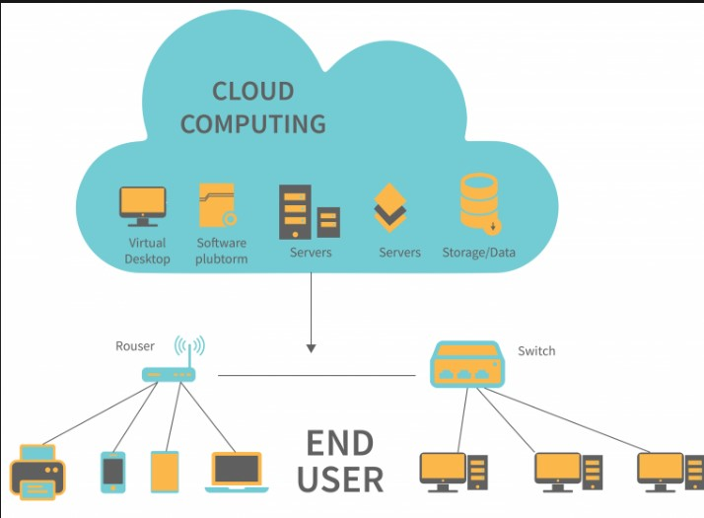

**Key Benefits**

* **Cost-Effective** – No need to buy hardware; pay for what you use.
* **Scalable** – Increase or reduce resources anytime based on your needs.
* **Accessible** – Use services from any location with internet access.
* **Automatic Updates** – Cloud providers handle maintenance and upgrades.
* **Disaster Recovery** – Data is backed up and can be recovered easily.

**Real-Life Examples**

* **Google Drive** – Store and share files in the cloud.
* **Netflix** – Streams movies using cloud servers.
* **Gmail** – Email service that runs entirely on the cloud.
* **Zoom** – Video conferencing tool using cloud infrastructure.

**Cloud Service Types and Providers**

**Types of Cloud Services**

* **IaaS (Infrastructure as a Service):**  
  Offers virtual machines, storage, and networking. You manage your own software and apps.
* **PaaS (Platform as a Service):**  
  Gives you a platform to develop, test, and deploy apps. The cloud provider manages everything except your code.
* **SaaS (Software as a Service):**  
  Ready-to-use applications like Gmail or Microsoft Teams. No setup required — just login and use.

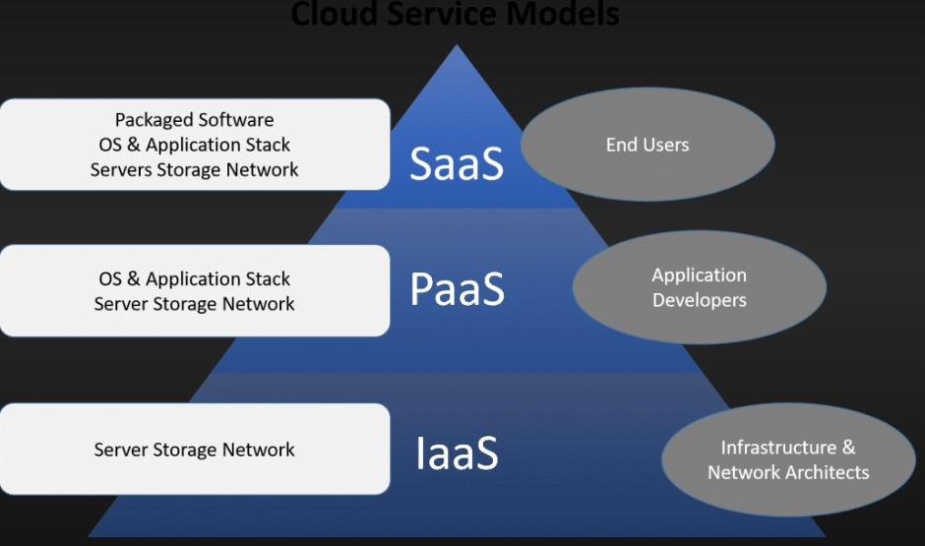

**Major Cloud Providers**

* **Amazon Web Services (AWS):**  
  Most popular cloud platform with a wide range of tools.
* **Microsoft Azure:**  
  Strong choice for businesses using Microsoft products.
* **Google Cloud Platform (GCP):**  
  Known for data analytics and AI capabilities.

**Security in Cloud Computing**

Cloud providers use technologies like **encryption**, **firewalls**, and **backup systems** to protect your data.  
Still, users must use **strong passwords** and manage **access permissions** carefully.

**Final Summary**

Cloud computing has changed how we use technology.  
It makes IT resources **easier, faster, and cheaper** to use.  
From watching movies to running a company, the cloud is part of everyday life.